Azure networking: VNet, DNS and boundaries
  - Portal-first beginner hands-on lab
LBS | Attendee edition v2 | 26 October 2026

Before you start
Environment: use the instructor-approved sandbox, group, region, tiers and spending limit. Create only your own disposable resources. The walkthrough uses fictional data. No cloud resource is created by reading this document.
Materials: copy Labs\AppServiceSqlSample locally when the lab needs the .NET sample. Complete its setup from 02_Windows_And_Local_SQL_Setup.docx. Do not repeat resource creation if you already completed the same lab in the main guide.
Admin assistance: Contributor does not automatically grant IAM role assignment, SQL SELECT, Blob data access or Service Bus data access. Have the authorised administrator perform only the privileged step. Never bypass policy.
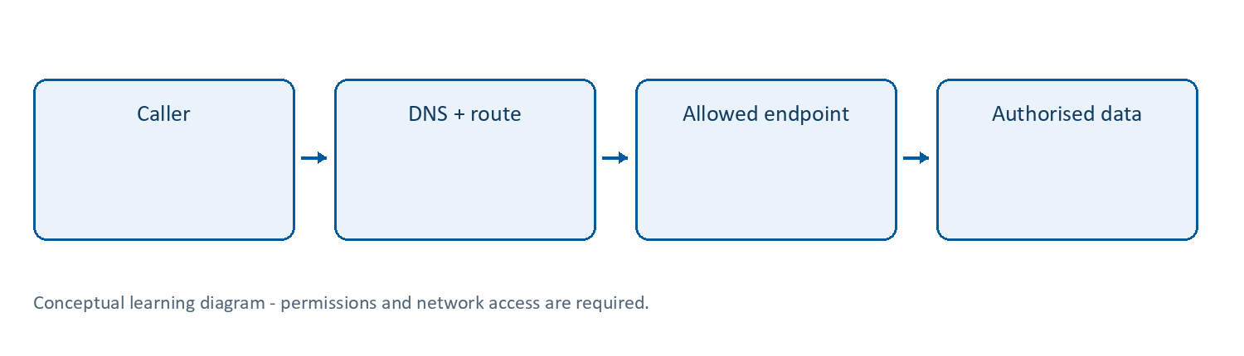
Learning flow

Lab 21 | Network basics: VNet, subnet, DNS and endpoint
What/why: distinguish identity permissions from network reachability. A correct token cannot fix a missing DNS route.
Needs: instructor-approved address space and permission to create an isolated VNet. This lab creates no VM, VPN gateway, NAT gateway or private endpoint.
Cost: avoid paid network attachments. Private endpoints, gateways and traffic can add charges; they are not needed for this introductory exercise.
- Search Virtual networks > Create and select your training group, region and a unique vnet-lbs-<suffix> name.
- Use the address range approved by the instructor (example only: 10.40.0.0/16). It must not conflict with planned connected networks.
- Add a subnet such as snet-practice with an approved subset (example only: 10.40.1.0/24). Record the range and leave delegation unset for this unconnected exercise.
- Keep paid optional gateways/firewalls/Bastion disabled unless explicitly assigned. Review and create.
- Open Subnets, Connected devices and DNS servers. No devices connected is expected; creating a VNet does not move your existing web app into it.
- Draw two independent paths: outbound VNet integration from App Service versus inbound private endpoint to a service. They solve different problems.
- On your own computer run a DNS check using a real endpoint:
Resolve-DnsName "<actual-sql-server>.database.windows.net"
- Record whether the result uses expected public/private DNS in the current network. Do not publish internal addresses broadly. DNS resolution alone does not prove TCP access or SQL authorisation.
- Inspect your service’s networking page without creating a private endpoint. Describe the extra dependencies: supported plan/integration subnet, endpoint, private DNS linking/forwarding, permitted routes and a client on the correct network.
Expected: isolated VNet/subnet created, diagram explains identity versus DNS versus routing, and no claim that App Service has been privately connected.
Stop condition: private connectivity is an administrator-guided follow-on lab, not a setting to guess. Do not enable a broad firewall rule as a shortcut.
Cleanup: delete only your empty practice VNet after checking Connected devices and dependencies. Do not delete a shared VNet or DNS zone.
References: https://learn.microsoft.com/azure/virtual-network/virtual-networks-overview and https://learn.microsoft.com/azure/app-service/overview-vnet-integration

Completion record and cleanup
Record | Your observation
Subscription/group/region and actual resource names
Expected result and actual result
Log/table/metric, time range and evidence
Identity, role/scope and network restrictions
Idle/usage/logging cost driver
Cleanup or retention owner/deadline
Only mark a lab passed after its functional checkpoint. A deployment success or empty error table alone is not proof. Mark blocked permissions honestly.
Clean up only your own disposable objects; removing a diagnostic setting does not erase retained logs, and stopping an app does not stop every cost. Follow Lab 13 in the main guide. Keep secrets/customer information out of evidence.
Confirm the current Azure scope, permissions, policy, runtime, region and pricing before starting. Record your own results; these instructions do not establish that your access or deployment works.

